

**CSC1310: lab 8**

File comparison using the **Queue** template class   
from the C++ Standard Template Library (STL)

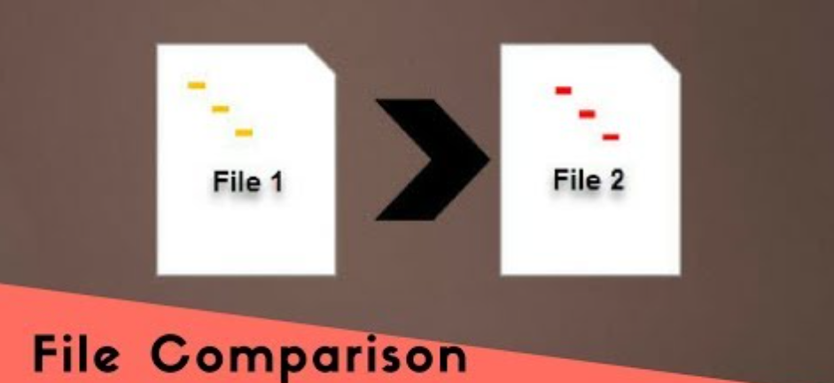

# what should this program do? (specifications)

Write a program (lab8.cpp) that will ask the user for two file names. You will read the characters from each file and put them in separate queues. Then, you will read each character from each queue and compare. If every character from both queues is the same, you will print “The files are identical.” Otherwise, you will print “The files are not identical.”

# Step-by-Step Instructions

1. Create a character queue (named **queue1**) using the Standard Template Library Queue class.
2. Create a second character queue (named **queue2**) using the Standard Template Library Queue class.
3. Ask user for first file name & read into a c-string.
4. Ask user for second file name & read into a c-string
5. Open first file for input.
6. Open second file for input.
7. Use a loop to read each character (one-at-a-time) from the file and push each character in queue1.
8. Use a loop to read each character (one-at-a-time) from the file and push each character in queue2.
9. Close the files.
10. While the two queues are not empty:
    1. Compare the front character from each of the two queues
    2. Remove (pop) a node from both queues.
11. If all of the characters were the same from both queues, print “The files are identical.”
12. Otherwise, print “The files are not identical.”

# Test Your Program

You need to download the appropriate text files for your operating system from ilearn.

First, run your program using fileA1.txt & fileA2.txt as your input. Your program should report “The files are identical.”

Second, run your program using fileB1.txt & fileB2.txt as your input. Your program should report “These files are not identical.”

# What to turn in

* Lab8.cpp
* fileA1.txt
* fileA2.txt
* fileB1.txt
* fileB2.txt